**Course Aims**

**T**o present the methodology and guiding principles of the Catechesis of the Good Shepherd for ages 3-6 in Level 1 and 6-9 in Level 2.

**T**o explore the general developmental characteristics, religious nature and the religious needs of the 3-6 or 6-9 year old child.

**T**o meditate on biblical and liturgical themes presented to the 3-6 in Level one and 6-9 year old child in Level 2.

To offer guidelines and assistance in creating a 3-6 for Atrium for Level 1 and 6-9 Atrium for Level 2, preparing the catechist’s album and materials.

**T**o broaden one’s ability to observe and learn from children, to listen with children to Scripture and to deepen one’s enjoyment of God’s presence.

***Nonrefundable Registration fee of $35***

***Due by April 30, 2025***

*This will be sent to the National Association of the Catechesis of the Good Shepherd.*

***Tuition of $500 due by***

***July date 17, 2025***

*For 90 hours of Instruction*

***Please make all checks out to***

***Chris Platko***

**Books Needed for Course**

*Religious Potential of the Child 1 (3-6 yr old)*

*Good Shepherd and the Joyful Journey*

*Nurturing the Whole Child by Gianna Gobbi*

Books can be purchased from the National Association of the Catechesis of the Good Shepherd (cgsusa.org)

or from Liturgy Training Publications (ltp.org)

**An Invitation to Join Us**

Implementation of the Catechesis of the Good Shepherd requires training for adults at each level or age group. Level 1 focuses on children ages 3-6, Level 2 ages 6-9, and Level 3, ages 9-12.

Each training level features almost 100 hours of lectures, lesson presentations and assistance with preparing materials and the catechist’s album filled with album pages (lesson plans).

The Level 2 course offered at St. John the Evangelist’s Atrium in Essexville, Michigan,

is the second step of acquiring all three levels of the Catechesis of the Good Shepherd.

**Course Dates**

**Level 1**

**Spring-Summer-Fall Course 2025**

**9 am-5 pm**

**1-May 31 (Sat)**

**2-June 26-27-28 (Thur-Fri-Sat)**

**3-July 17-18-19 (Thur-Fri-Sat)**

**4-August 7-8-9 (Thur-Fri-Sat)**

**5-September 6 (Sat)**

**6-October 4 (Sat)**

**7-November 1 (Sat)**

**Course Location**

**St. Jude Thaddeus Parish Office**

*(formerly St. John the Evangelist)*

614 Pine Street Essexville, Michigan

Rose Yagiela Formation Leader:

Home machine 989-893-1788

Cell 989-327-9294

Chris Platko cell: 989-860-9957

**Course Leader: Rose Yagiela**

**Work:**

**Catechesis of the Good Shepherd since 2001.**

**Director of Elementary FF**

**Catechist & Coordinator**

Prepared Atriums: making all materials for

3 Level 1’s, 2 Level 2’s, and 1 Level 3 Atriums

**Diocesan DRE Advisory Team**

**Retired Director of Music & Liturgy**

**St. John the Evangelist now St. Jude Thaddeus Parish since 1988.**

**Masters Rel. Education (in progress)**

Assumption University Windsor, Ontario

In conjunction with Diocese of Saginaw

**Bachelors of Arts Degree 2001 SVSU Undergrad** University of Michigan Delta College

**Personal:** Married since 1981 to husband Tim.

Sons: Ken and Patrick with Daughter in law Melissa and grandson Connor and Owen.

**Course Assistant: Chris Platko**

Catechesis of the Good Shepherd since 2004  
**Work:**   
Director of Faith Formation (children and adults) for 20 plus years

Built two Level One Atriums

Diocesan Advisory Team member

**Current Employment and Volunteer Ministries:**

St. Catherine of Siena Parish, Bay City  
St. Elizabeth School/Reese  
 (CGS Coordinator/Catechist)

Holy Spirit/Saginaw (CGS Catechist)  
Christ the Good Shepherd (CLI Team Leader for Next Generation Parish)   
**Education:**  
Master of Arts in Religious Education (2009)  
 Assumption University Windsor, Ontario  
 In conjunction with Diocese of Saginaw

Currently working toward Formation Leader Certification Level 1 (CGS/USA)  
**Personal:** Married to Dave 45 years.   
Children: Beth and Ben and three grandchildren.

**REGISTRATION FORM**

Catechesis of the Good Shepherd Level 1 Training

***Nonrefundable Registration***

***Fee of $35.00 for Level 1***

***Checks made out to the***

***Chris Platko***

***Due by April 30 with***

***Tuition of $500 due by July 17, 2025***

***Made out the Chris Platko***

**Participant’s Information Fill out Below:**

Name_______________________________________

Address_____________________________________

City/Zip______________________________________

email_______________________________________

Phone_____________________________Cell______

Parish_______________________________________

***We will have an Hour lunch break so you can either bring your lunch or go out for Lunch at nearby restaurants.***

______________________________________

***Catechesis of the Good Shepherd***

The goal of this Montessori-based program is to help the child enjoy and be in love with God, first proclaimed as Jesus, the Good Shepherd in level one and then as the True Vine in level 2 such a relationship is the strongest possible foundation for life-long spiritual growth and moral living.

The Catechesis, grounded in Scriptural and Liturgical study, is framed by Maria Montessori’s principles of education. Children hear the Gospel by working with sensorily rich, but simple materials, keyed to scriptural and Liturgical moments. After the introduction, children are free to work on their own with these materials.

Central to catechesis is the Atrium, a sacred space prepared for the children. A place of beauty, the atrium is designed for being with and enjoying God, listening to God’s Word, and praying.

Since 1954, Sofia Cavalletti, a Hebrew and Scripture scholar and member of the Vatican commission for Jewish-Christian relations, and her colleague, professor Gianna Gobbi, a Montessori trained educator, have developed the Catechesis by observing and working with children at the Children’s Centre in Rome, Italy.

They discovered that, in any culture, the vital religious needs of children during a particular age range and the essential elements of the faith which meet those needs are constant. The joyful peaceful, response of the children themselves inspired and determined the content of this unique program.

***Catechesis of the***

***Good Shepherd***

***Level 1 Course***

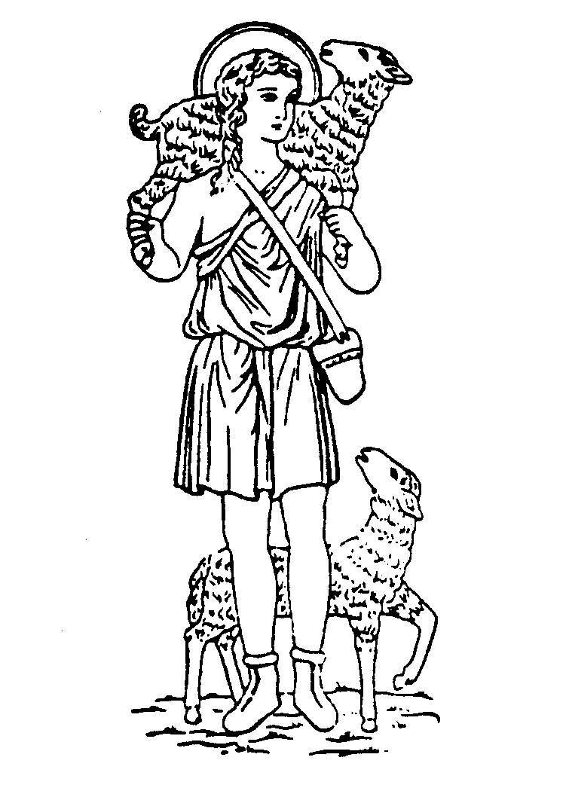

National Certificate Training Series

For Catechists and Leaders

Level 1

**May, Sept, Oct, November**

(Saturday 9-5)

**June, July & August**

Thursday, Friday, & Saturday (9-5)

90 hours of training

Formation Leader: Rose Yagiela assisted by Chris Platko

St. Jude Thaddeus Parish

St. John the Evangelist Church site

614 Pine Street Essexville

Home 989-893-1788

[rose_gsformationleader@hotmail.com](mailto:rose_gsformationleader@hotmail.comChris)

Chris Platko 989-860-9957

clplatko@sbcglobal.net